Cross Sell Model

# **Cross-Sell Model Documentation**

# **Introduction:**

# The Cross-Sell Model is a monthly process that aims to provide tailored product recommendations to customers based on their existing holdings and product usage history. This model leverages a collaborative filtering approach, taking into consideration the age of the products held by customers and their similarity to other customers. The goal is to enhance customer engagement by suggesting relevant products that align with their financial needs.

# **Model Flow:**

# 1. **Data Collection:** The process starts by collecting information about customers' held products, including the age of each product (i.e., how long the product has been held by the customer). This data serves as the foundation for generating personalized recommendations.

# 2. **Standardization:** To account for differences in customers' ages and the length of time products have been held, a standardization process is applied. This involves calculating a standardized rating by dividing the product age by the customer's age. This standardization ensures fair comparisons between new and existing customers.

# 3. **Collaborative Filtering:** The standardized product ratings are used for collaborative filtering. This step involves measuring the similarity between customers based on their product holding patterns and standardized ratings. Cosine similarity is employed to determine how alike customers are in terms of their product preferences.

# 4. **Similarity Selection:** For each customer, the 30 most similar customers are identified based on the calculated cosine similarity scores. These similar customers serve as peers to inform the recommendations.

# 5. **Product Exclusion:** The products already held by the target customer are excluded from consideration. This ensures that only new, relevant products are recommended.

# 6. **Recommendation Generation:** From the pool of similar customers, the two topmost products that appear in their holdings are recommended to the target customer. These recommendations are generated by identifying common preferences among peers.

# **SQL Query for Product Age Calculation:**

# An SQL query is employed to fetch the product age, which indicates the length of time each product has been held by the customer. This data is crucial for standardization and collaborative filtering steps. The query takes into account various product categories and calculates the age of each product based on the opening date and current date.

# **Model Implementation:**

# The Cross-Sell Model is implemented in a systematic manner, integrating data collection, standardization, collaborative filtering, and recommendation generation. The model's components are designed to work together harmoniously, resulting in accurate and relevant product recommendations for each customer.

# **Model Output and Storage:**

# The recommendations generated by the Cross-Sell Model are saved in a structured format that includes the recommended products, their scores, and the associated customer. These outputs contain detailed notes reflecting the steps taken during the model execution. Additionally, the SQL query used to fetch the product age is provided to offer transparency and traceability in the process.

# **Conclusion:**

# The Cross-Sell Model enhances customer engagement by providing personalized product recommendations based on their existing holdings and product usage patterns. By considering the age of products, standardizing ratings, and applying collaborative filtering, the model ensures that the recommendations align with each customer's financial journey and preferences. This systematic approach contributes to a more tailored and relevant customer experience.SQL query – prod_age_rec.sql

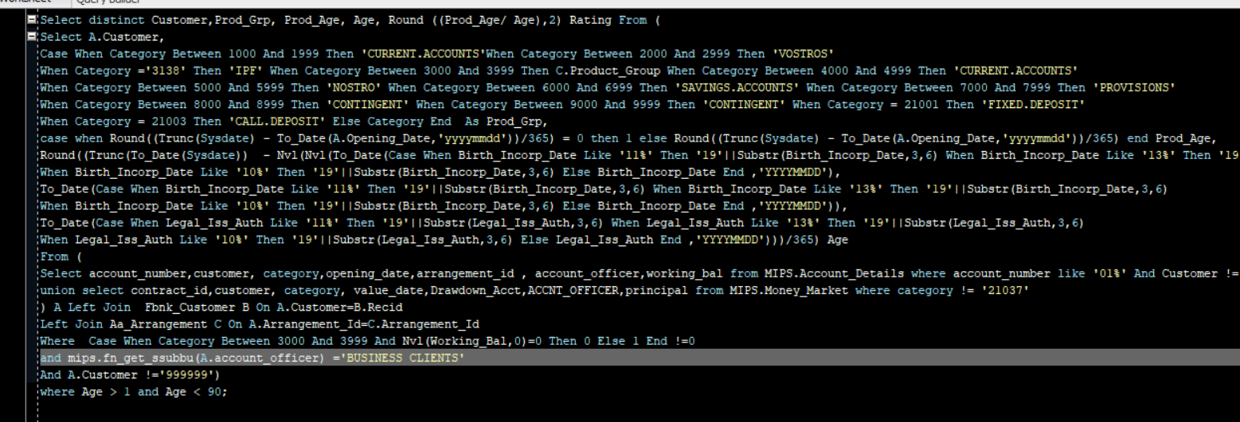

# CHNW – cross_sell_chnw.ipynb

*Initialization of the model run*

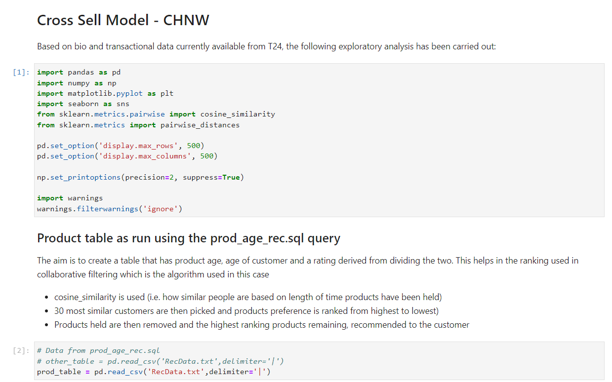

*Getting the similarity between customers*

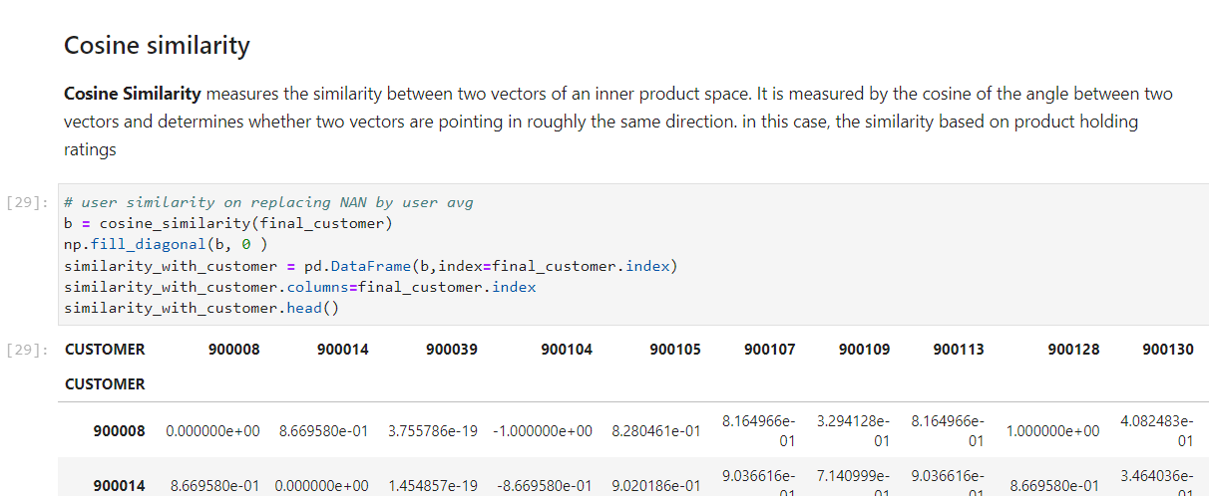

*Getting the highest ranked recommended product per customer*

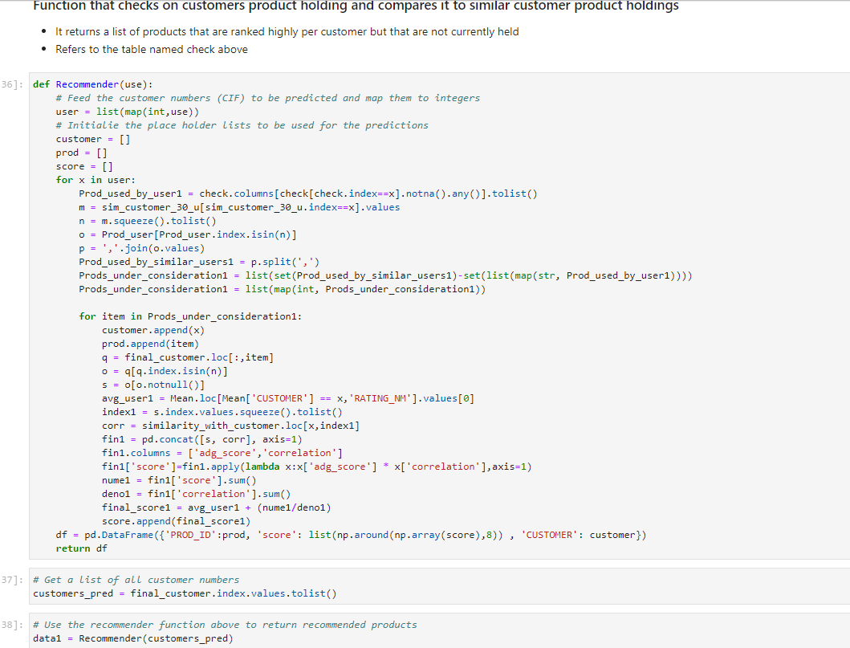

*Recommendations are uploaded to kenyaleads.*

NOTE: Both notebooks follow a similar run book, difference being the customer product eligibility